**UNO R3 DRIVER FAQ**

If the following steps can't solve your problem, please feel free to drop us a line at

lafvin_service@163.com

Please make sure that your IDE is updated to 1.0.5 or newer version

1) If you connect the Controller board to your computer, the computer does not response.

Open the Device Manager by right clicking “My computer” and selecting control panel.

Look under Ports (COM & LPT). If there is no COM or LPT or there is only an unknown device, it means there are some issues with the controller board or the USB cable.

We are sorry for the inconvenience caused. Please contact us.

1. Open the Device Manager by right clicking “My computer” and selecting control panel.

Look under Ports (COM & LPT). If there is only an ATMEGA16U2.

It means that the Firmware of ATMEGA16U2 chip is wrong. Please contact us.

1. The company is installing the driver all the time but fails finally.

Please download the drivethelife from the following website: <http://www.drivethelife.com/>

Install the software > Install the driver automatically > Restart the computer.

1. Open the Device Manager by right clicking “My computer” and selecting control panel.

Look under Ports (COM & LPT). If there is an Arduino UNO with yellow exclamation mark. It means that you should install the driver by yourself.

***How to install:***

# If your computer is XP System:

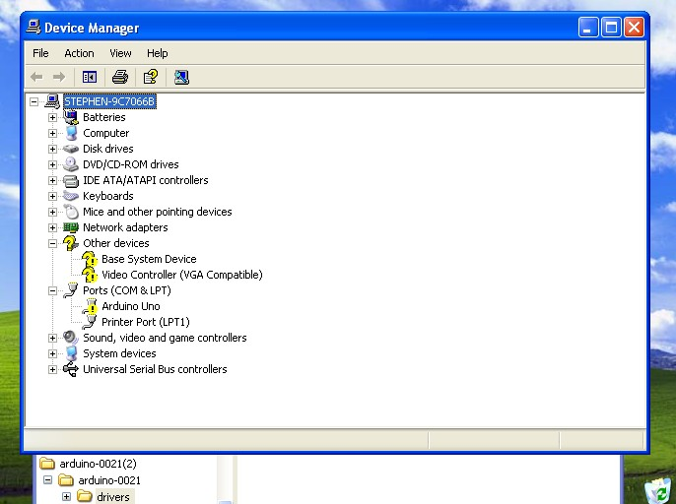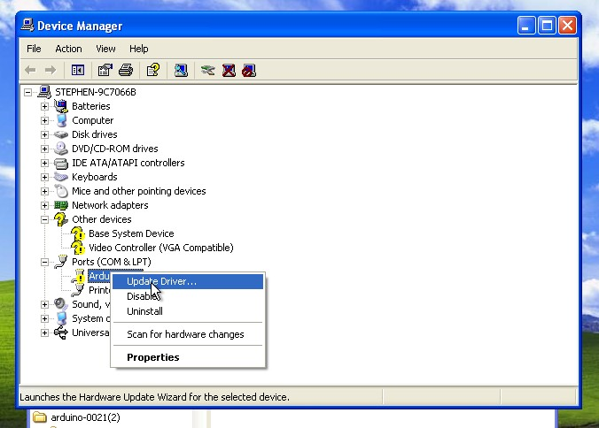

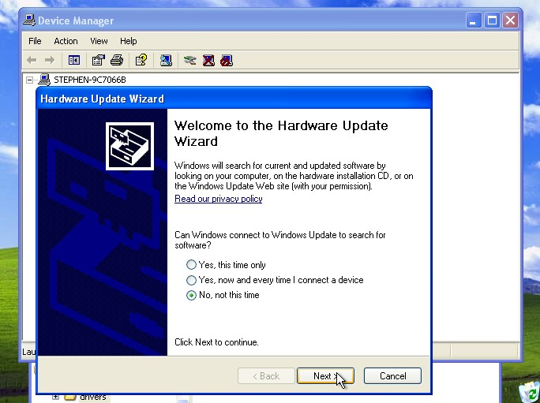

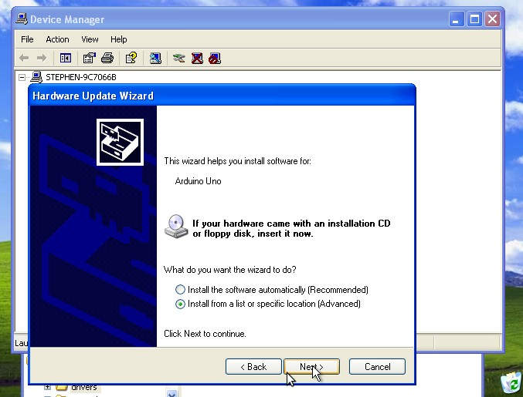

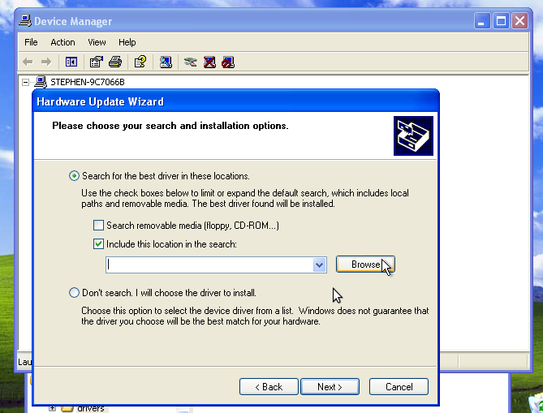

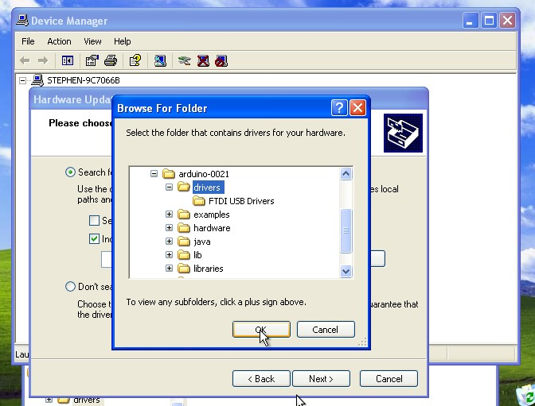

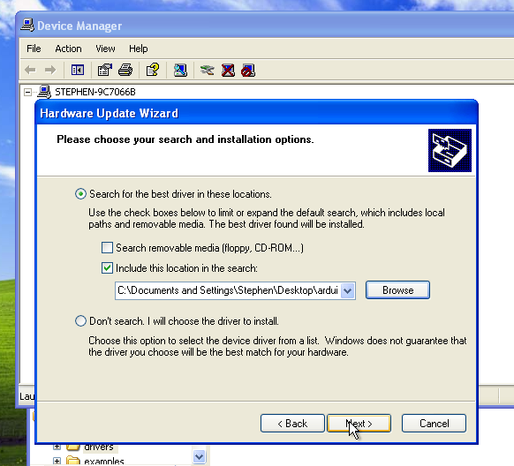

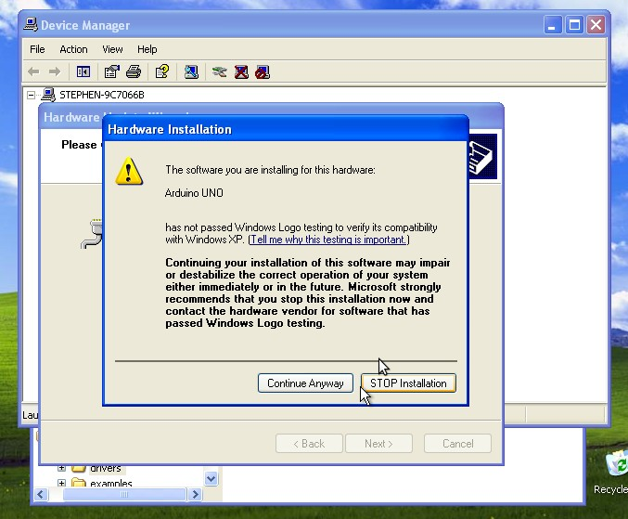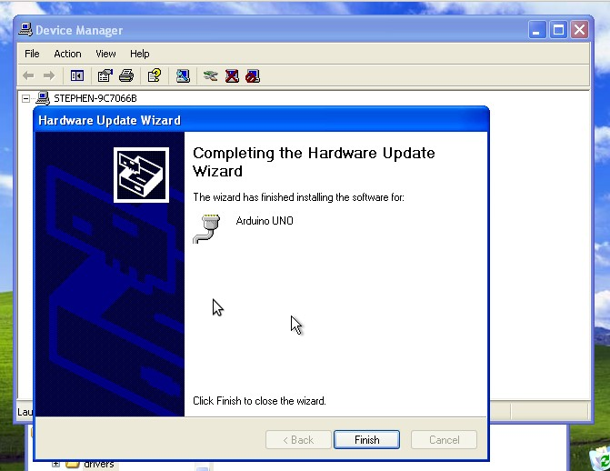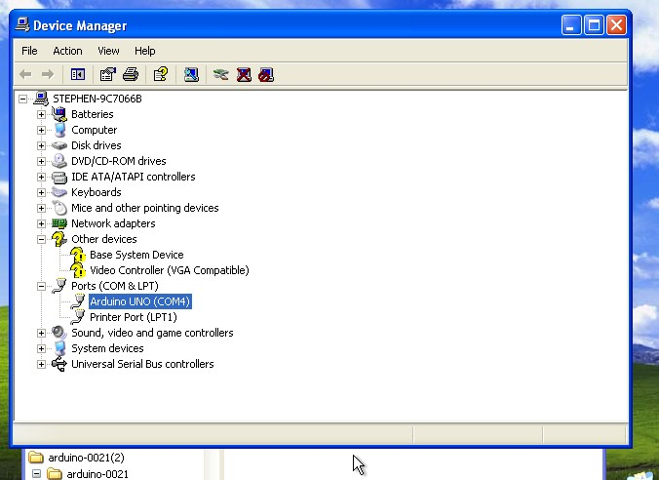

**If your computer is win7 system:**

Open the Device Manager by right clicking “My computer” and selecting control panel.

Look under Ports (COM & LPT). You should see an open port named "USB Serial Port" Right click on the "USB Serial Port" and choose the "Update Driver Software" option.

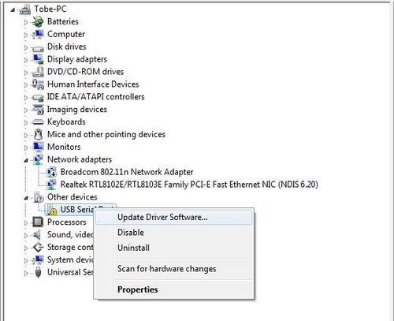

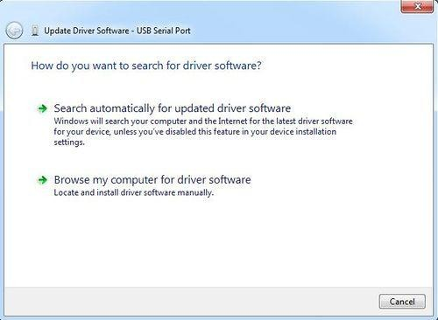Next, choose the "Browse my computer for Driver software" option.

Finally, select the driver file named "FTDI USB Drivers", located in the

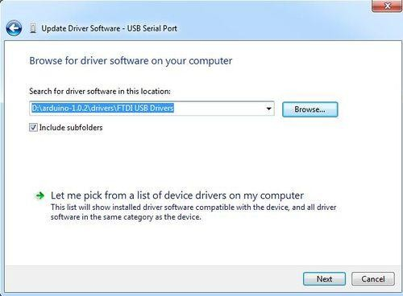"Drivers" folder of the Arduino Software download.

The below notification would automatically appear if you have installed driver successfully.

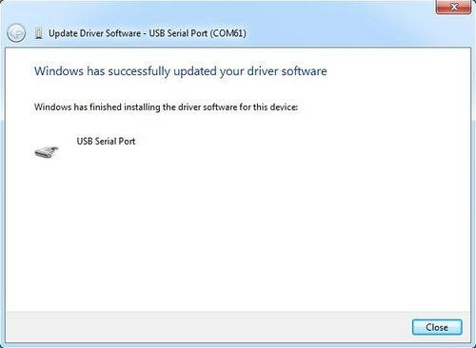

You can check that the drivers have been installed by opening the Windows Device Manager. Look for a "USB Serial Port" in the Ports section.

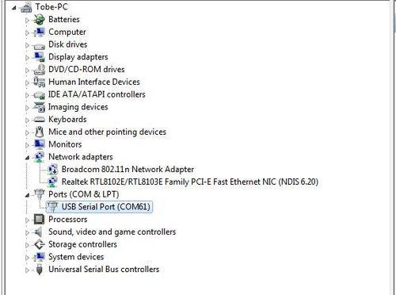

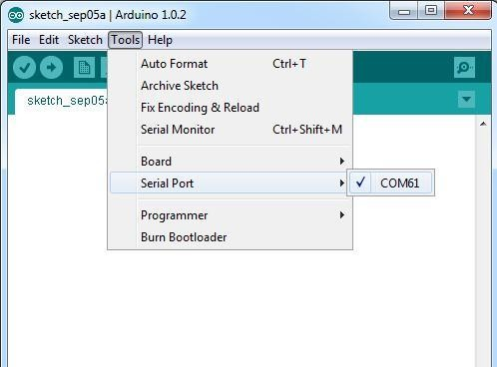You can also see the serial port in Arduino environment.

# If your computer is window8 system:

You should save these files which you are editing before installing driver with window8 because there will be several power off during operation.

* + Press “Windows Key” +”R”
  + Enter shutdown.exe /r /o /f /t 00
  + Click the "OK" button.
  + System will restart to a "Choose an option" screen
  + Select "Troubleshoot" from "Choose an option" screen
  + Select "Advanced options" from "Troubleshoot" screen
  + Select "Windows Startup Settings" from "Advanced options" screen
  + Click "Restart" button
  + System will restart to "Advanced Boot Options" screen
  + Select "Disable Driver Signature Enforcement"
  + Once the system starts, you can install the Arduino drivers as same as Windows

# If your computer is Mac OS system:

Enter page: [http://www.ftdichip.com](http://www.ftdichip.com/).

Download Driver for the Mac OS X version, named 2.2.18 (32bit)

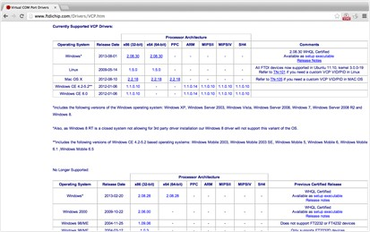

Open the driver file which you just download, and double click FTDIUSBSerialDriver_10_4_10_5_10_6_10_7.mpkg

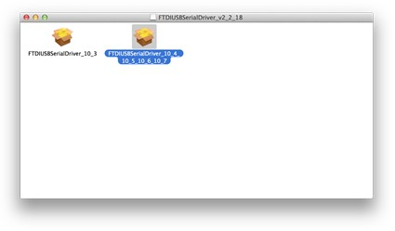

After double click, you will see an installer window.

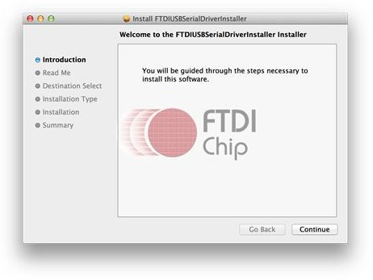

Click “Continue”.

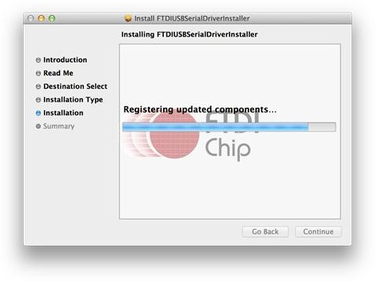

You can see the below dialog boxes if you have installed driver successfully.

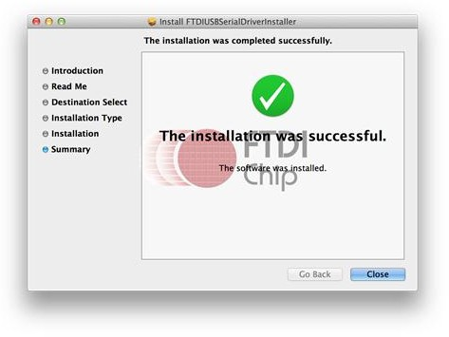

Test it with Seeeduino

